A1315-AM,S-Peru-South Coast-Late Intermediate (Chimu) Period-1000-1450 AD/CE

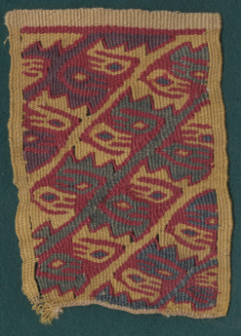 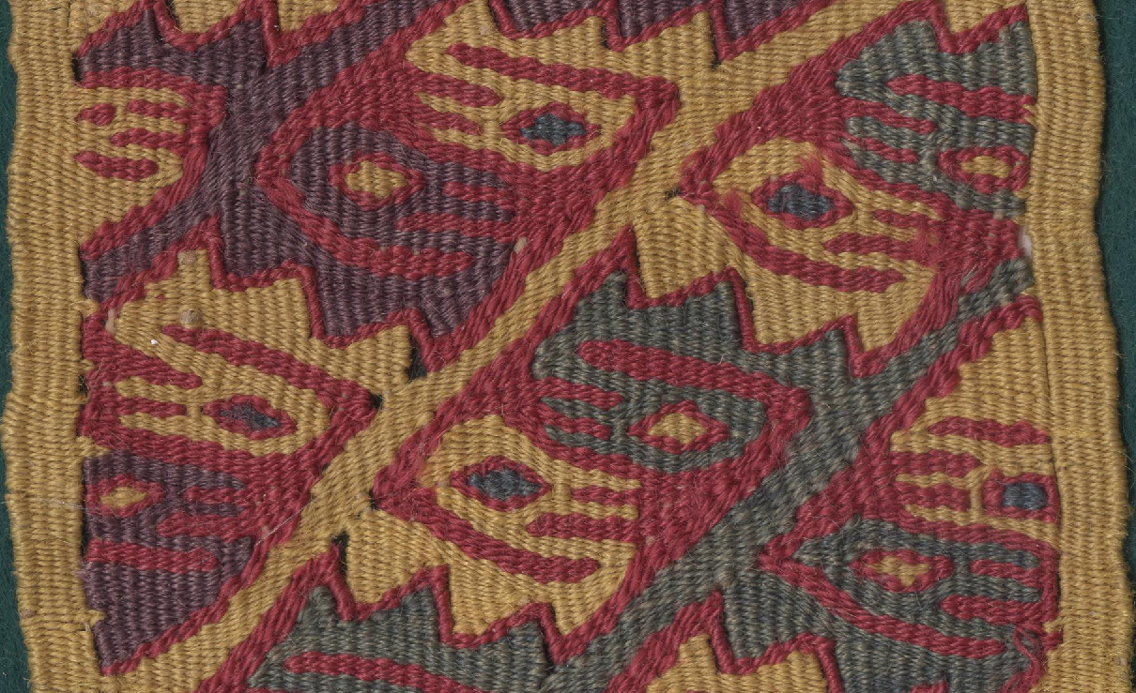

Fig. 1. Peru-South Coast-Late Intermediate (Chimu) Period-1000-1450 AD/CE

**Case no.: 7**

**Accession Number: A1315**

**Formal Label:** Peru-South Coast-Late Intermediate (Chimu) Period-1000-1450 AD/CE

**Display Description:**

The period of this textile panel Late Intermediate (Chimu) Period-1000-1450 AD/CE when the Chimu, also a coastal culture, emerged ca 900 and expanded from the Moche Valley north of present-day Lima to conquer the Tiahuanaco and Huari kingdoms to the south. Burgeoning populations on the coast, intense Chimu infiltration and internecine fighting among splintered Tiahuanaco and Huari groups prompted Conquistadors to refer to these petty states as *pequeños reinos*, “little kingdoms.”

This political fragmentation was reflected in the extreme variety of textile design motifs, as each petty state wished to exceed the others both politically and artistically. For instance, this polychromatic abstract textile design of formalized birds repeated head to head is structured within a geometric arrangement in diagonal rows that produces a mosaic-like pattern. Its intricacy was a prized achievement that demanded an artistic response. The principal motifs of this art, which has an underlying unity within extreme variety in details and vegetable colors, reflects the previous Tiahuanaco–Huari style as a foundation for this art. The colors employed in this panel reflect a repertoire of plant dyes to produce the gold, red, green and purple.

**LC Classification:** F3319.1.T55

**Date or Time Horizon:** 600-1000 CE

**Geographical Area:** Intermediate (Chimu) Period

**Map, GPS coordinates: 16º33'15.15" S 68º40'41.65" W**

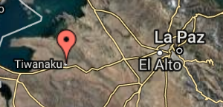

**Cultural Affiliation:** Intermediate (Chimu) Period

**Media:** wool, vegetable dyes

**Dimensions:** various

**Weight: various**

**Condition: original**

**Provenance:** unknown

**Discussion:**

This panel is probably a brocaded border in a slit tapestry.

**References:**

Anton, Ferdinand. 1984. *Ancient Peruvian Textiles*. London: Thames and Hudson.

Protzen, Jean-Pierre. 2013. *The stones of Tiahuanaco: a study of architecture and construction*. Los Angeles: Cotsen Institute of Archaeology Press, University of California, Los Angeles